Name of Student
Name of Instructor
Course
Date

Part 2: Organization of data
The study is observational as the research team collected data from patients who were doing their normal daily activities. The researchers simply collected data
The data is quantitative. This is because the data represents a characteristic that is measurable in numbers. The heart rate is the number of beats the heart makes per minute.
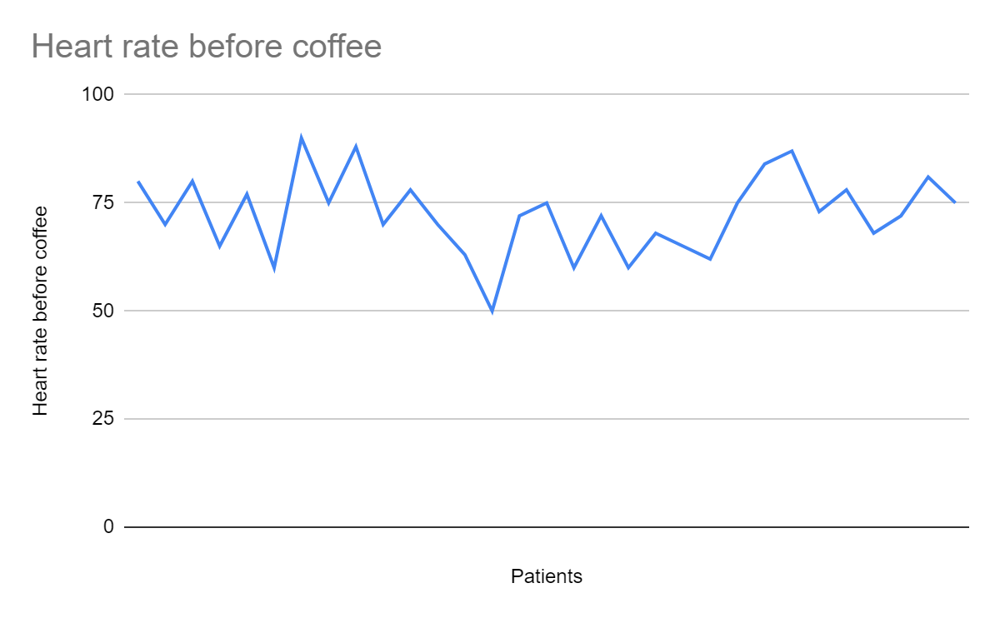
The graph shows the heart rates of the patients who had been involved in the study. The lowest number of beats is 50 and the highest is 88 beats per minute.
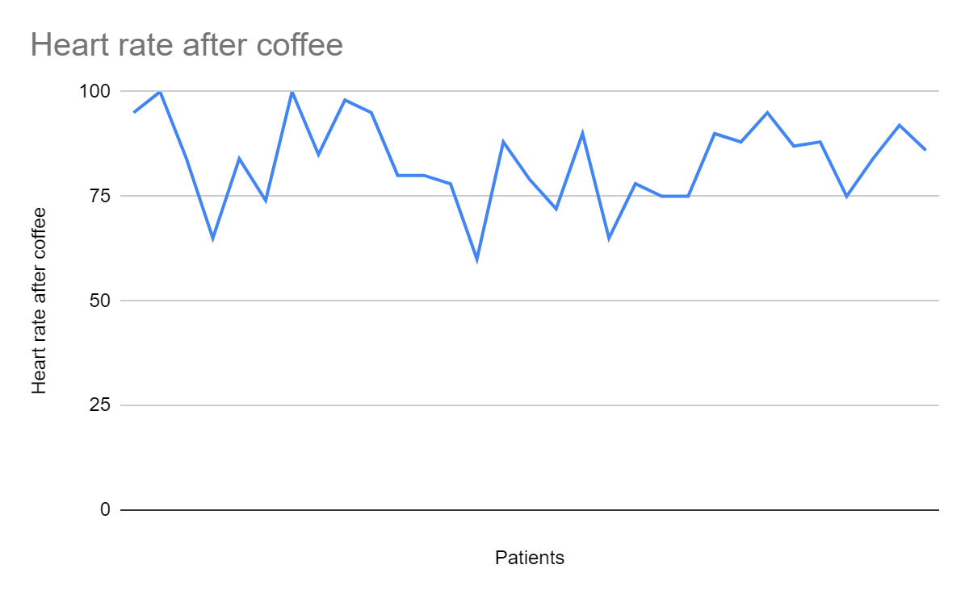
The graph shows that after the patients took coffee their heart beats increased. The lowest number of heart beats has risen to 60 while the highest is at 100 beats per minute. The second graph has shifted significantly after the patients took coffee.
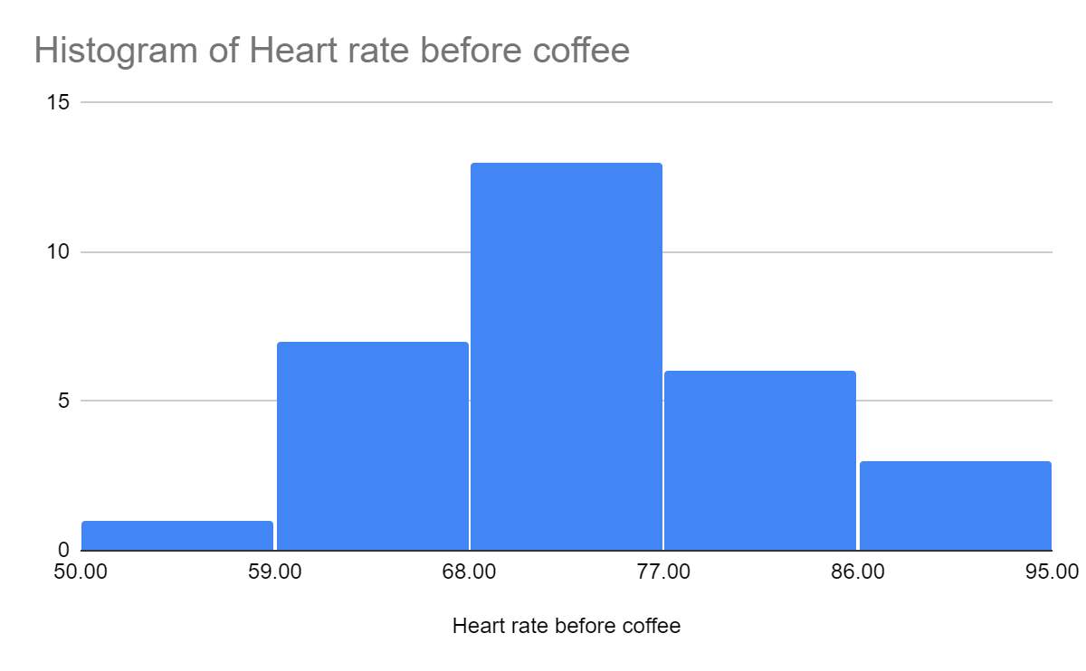
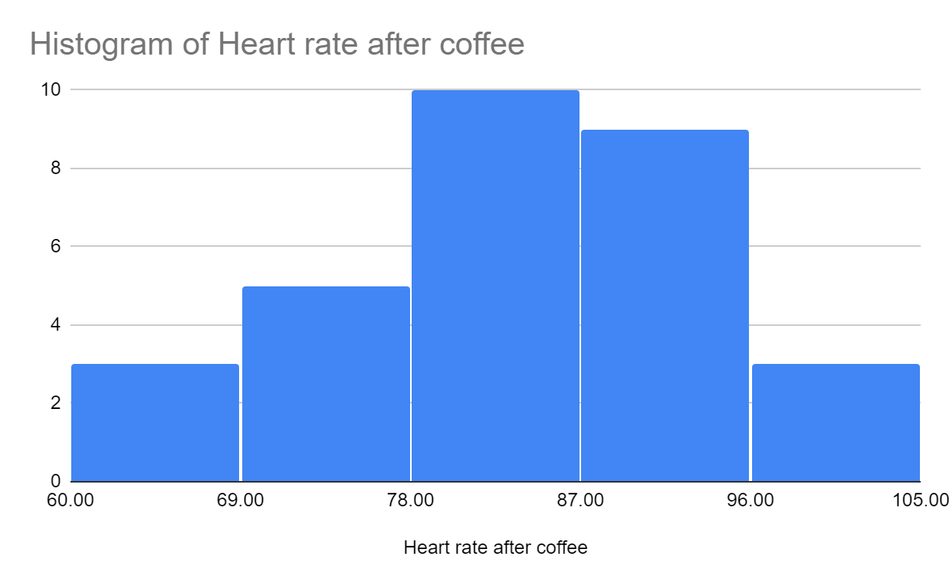
The data is normally distributed.
Measures of Central Tendency

Heart rate before coffee
Mean | 72.35483871
Median | 72
Mode | 75

The mean, mode and median of the above data sets are close to each other. This shows that the data is normally distributed without outliers or other inconsistent values.

Standard Deviation | 9.178047676
Sample Variance | 84.23655914
Kurtosis | 0.01387555566
Skewness | -0.1677857097
Range | 40
Sum | 2243
Count | 31

The standard deviation is 9.178 which is small for a small for a sample with a range of 40. It shows that the values of the sample are not very far away from the mean.
Heart rate after coffee
Mean | 83.38709677
Median | 84
Mode | 95

The mean and median are very close together which shows that they are the best measures of central tendency for the data set.

Standard Deviation | 10.28162574
Sample Variance | 105.711828
Kurtosis | -0.2899222476
Skewness | -0.3672639432
Range | 40
Sum | 2585
Count | 31
The standard deviation is 10.28 which is also small for a sample with a range of 40. It shows that the values of the sample are not very far away from the mean.
Heart rate before coffee

Minimum | 50
Maximum | 90
Median | 72
Q1 | 66.5
Q3 | 78
The data above shows that the samples values lies between 50 and 90 with the value at the middle being 72. The first and third quartile shows how the data is distributed in the two halves of the data.
Heart rate after coffee

Minimum | 60
Maximum | 100
Median | 84
Q1 | 76.5
Q3 | 90

For the second data, the values lies between 60 and 100 with a similar range of 40 as the first data set. The middle value is 84 and the quartiles describe the data further within the sample. The second data set has larger values as compared to the first. This shows that the heart rate during the first data collection session was lower as compared to the second time the data was collected.
Outliers for Heart rate before coffee
Q3 - Q1 = IQR
78 - 66.5 = 11.5

1.5 x IQR
1.5 x11.5 = 17. 25
66.5 - 17.25 = 49.25
78 + 17.25 = 95.25
Any values below 49.25 and those above 95.25 are outliers

Outliers for Heart rate after coffee
Q3 - Q1 = IQR
90 - 76.5 = 13.5

1.5 x 13.5 = 20.25
76.5 - 20.25 = 55.25
90 - 20.25 = 110.25

The data has no outliers.
Consequently the results obtained after any calculations or visualization will not be skewed by inconsistent data.
There are no errors that should be corrected.

Part 2: Analysis of data
The null hypothesis of the study is that an increase in the amount of caffeine will not have any effects on the heart rate
The alternative hypothesis is that an increase in caffeine will lead to a subsequent increase in the heart rate.

$H_{0}$: ${ℳ }_{2}= {ℳ }_{1}$
$H_{1}$: ${ℳ }_{2} >$${ℳ }_{1}$

The test to use is the t-test for two independent means since the values of each data set do not depend on the other set. Additionally, the sample size is greater than 30. A two sample t-test for unpaired data will be used to test whether ${ℳ }_{2}$ is significantly greater than ${ℳ }_{1}$.
The test is appropriate at it shows the relationship between the two variables. The relationship will help determine whether to accept or reject the null hypothesis.

N₁: 31
df₁ = N - 1 = 31 - 1 = 30
M₁: 72.35
s²₁ =84.24

N₂: 31
df₂ = N - 1 = 31 - 1 = 30
M₂: 83.39

s²₂ = 105.71

s²_{p} = ((df₁/(df₁ + df₂)) * s²₁) + ((df₂/(df₂ + df₂)) * s²₂) = ((30/60) * 84.24) + ((30/60) * 105.71) = 94.97

s²_{M1} = s²_{p}/N₁ = 94.97/31 = 3.06
s²_{M2} = s²_{p}/N₂ = 94.97/31 = 3.06

t = (M₁ - M₂)/√(s²_{M1} + s²_{M2}) = -11.03/√6.13 = -4.46
P value = 0.000018
Critical value for the upper tail= $t_{1-a/2,v}$
Level of significance $a$= 0.05
T-value = 2.00
When the absolute of the t-statistic is greater than the critical value, then the null hypothesis is rejected.
We reject the null hypothesis and accept the alternative that an increase in caffeine will lead to a subsequent increase in heart rate.

The results show that there is enough evidence to reject the claim that caffeine does not have any effect on the heart rate. The results show that an increase in caffeine causes a resulting increase in patients heart rate.

